The Font

Fostering connections within the Order of Saint Luke January/February 2004
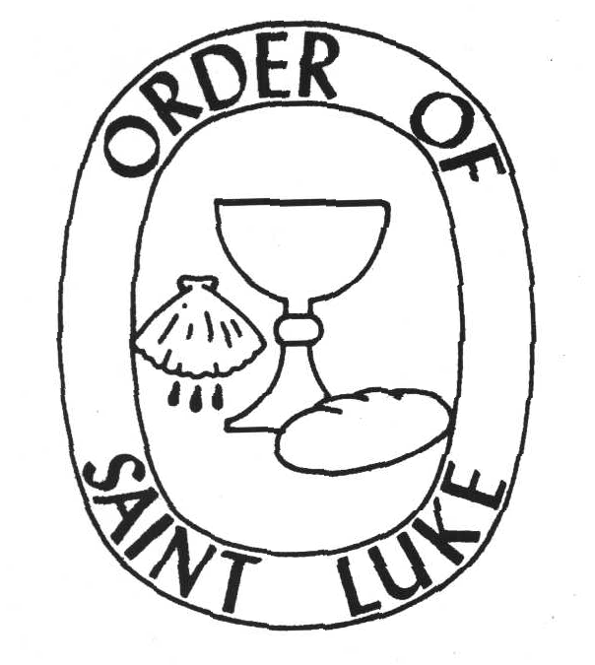

From the Abbot’s Desk

Contact the Abbott Mark Stamm, O.S.L. at mwstamm@comcast.net

Dear Sisters and Brothers,
Grace to you, and peace, in Jesus Christ our Lord. I hope this letter finds you well.

In the opening paragraph of our Constitution, we call ourselves a dispersed religious community. What is a dispersed community, anyway? The dispersed part is easy enough to understand most days, but what about the community part?

My sense of community in diaspora has been strengthened by chapter and retreat gatherings. This year’s annual retreat at the Old Mission in Santa Barbara was a good mix of fellowship, worship, and learning in a wonderful location. Br. Stanley Tanner, our Prior General, allowed us plenty of time for reflection, conversation, and the building of relationships. We had barely returned home from the retreat when the wildfires presented some of our California sisters and brothers with a significant pastoral and personal challenge. Those leisured conversations we had shared the week before helped deepen my prayers in support of them.

It is important that we meet together whenever we can, even if that means arranging to meet for lunch, conversation, and praying the mid-day office when you’re visiting the hospital near a colleague’s neighborhood. Many of us sing the hymns, psalms, and canticles of the daily office and say the prayers aloud as a way of embodying our claim that the office prayed in physical solitude is in fact the prayer of the full Order and yes, the prayer of the Church. That claim makes more sense when we’ve spent some time praying in each other’s presence, even if that other is just one sister or brother whom we meet occasionally.

Having praised small gatherings, I will speak of the larger gathering as well. Gathering for annual retreat is not always easy, both logistically and financially, but the benefit is great. Planning ahead increases the likelihood of your attending. Convocation is tentatively scheduled for Oklahoma City, OK, October 18-21, 2004. So, circle the dates on your calendar and set aside the time now. Shop for airfares. Ask the grandparents to come watch the kids. Check your Conference and District and Student Association offices and ask about event and continuing education scholarships—such funds often go unclaimed. Why shouldn’t you use them this year? If you are able, you might also consider offering a full or partial retreat scholarship to a newer member of the Order.

I hope you can find a way to join us next fall.

Your brother,
Mark W. Stamm

Ordo for the Order of Saint Luke

JANUARY

T 1 The Holy Name W

F 2 W

S 3 Gilbert Haven W
Eve of Epiphany W (optional)

S 4 2nd Sunday after Christmas W

The Epiphany W (optional)
M 5 W
Eve of Epiphany W (trad)

T 6 The Epiphany W (trad) or G *

W 7 G *

T 8 Richard Watson G *
F 9 G *

S 10 G *
Eve of the Baptism of the Lord W

S 11 Baptism of the Lord W
M 12
T 13 George Fox G

W 14 G
T 15 Martin Luther King, Jr. G
F 16 Hiram Rhoades Revels G
S 17 Antony of Egypt G

S 18 2nd Sunday after Epiphany G
M 19 The Confession of Peter W (trans)

T 20 G

W 21 Agnes of Rome G

T 22 G

F 23 Sarah Ann Dickey G

S 24 Eli Stanley Jones G

S 25 3rd Sunday after Epiphany G
M 26 The Conversion of Paul W,-(trans)
T 27 John Chrysostom G
W 28 Thomas Aquinas G
T 29 G
F 30 G
S 31 John Raleigh Mott G

* Some traditions continue to use white until The Baptism of The Lord

FEBRUARY

S 1 4th Sunday after Epiphany G

M 2 The Presentation W

T 3 G
W 4 Cornelius the Centurion G
T 5 Philipp Jakob Spener G

F 6 G
S 7 G

S 8 5th Sunday after Epiphany G
M 9 G

T 10 G

W 11 Fanny Jane Crosby G

T 12 G
F 13 Absalom Jones G

S 14 G

S 15 6th Sunday after Epiphany G
M 16 G
T 17 Frances Elizabeth Caroline Willard G

W 18 Martin Luther G
T 19 G
F 20 Frederick Douglass G

S 21 Ezekial Cooper G
Eve of the Transfiguration of the Lord W

S 22 Transfiguration of the Lord W

M 23 Polycarp G

T 24 Matthias R

W 25 Ash Wednesday P

T 26 P

F 27 George Herbert P

S 28 P

S 29 1st Sunday in Lent P

Ordo prepared by Br. Jack Fahey

From the desk of the Prior General

Contact Prior General Stanley Tanner, O.S.L. at stanosl@aol.com


The 2004 Convocation and Retreat of The Order of Saint Luke will be held 18-21 October, in the Pastoral Center of the Archdiocese of Oklahoma City, Oklahoma. The subject of our gathering will be the report to the General Conference of the United Methodist Church of the Holy Communion Study Committee, entitled This Holy Mystery. We expect to have with us Dr. Ed Philips, chairperson of the Committee, Dr. Karen Westerfield Tucker, one of the members of the Committee, and receive a presentation from Dr. Mark Stamm, Abbott of the Order.
We encourage you to begin making your plans to join us for an exciting time. More details will be shared as they become available.

Grace and Peace from StLukesintheWood
Stan Tanner, Prior General

Nominations Chairman Named for Officers for General Chapter
At the October Council meeting, Brother David Eichelberger accepted appointment as chair of the nominating committee, which will meet at the spring 2004 meeting of the Council. This committee will nominates person for Abbot, Prior General, Chancellor General, and Provincial General. (All other offices are appointed or are decided locally.)

The Constitutional statute (IV.7) reads as follows: "Nomination of the four elected general officers will be made by a Nominating Committee composed of the Priors or representatives of Chapters and Associations in attendance at the Spring Meeting of the Council prior to the General Convocation. The Nominating committee shall prepare a slate that will be mailed to the membership. All members in good standing shall be eligible to vote. Unless otherwise determined by the Council, the officers shall be invested at the next General Convocation."

Members of the Order are invited to send suggestions for nominees to Br. David, although you should check first with the prospective nominee.

As you consider persons for nomination, you need to be aware that:
- Any professed member (life vows or annual vows) of the Order may be nominated and elected to office.
- Current officers may be elected to succeed themselves.

Nominations can be sent by email to DavidEOSL@aol.com or by mail to Rev. David A. Eichelberger, O.S.L., 539 South Fourth Street, Aurora, IL 60505. They should be posted no later than April 15 if sent by mail or no later than April 25 if sent by email.

News from O.S.L. Publications

Under the Tree of Life, by Gail Ramshaw

Kathleen Norris says of Ramshaw's Under the Tree of Life that it "will be of use to people who are making their way back to church, or wondering why they're still there. . . . [Ramshaw's] love of metaphor and respect for the powerful symbols of the religious imagination illuminate the book, and make for an invigorating read."

Perhaps you are looking for "an invigorating read" for yourself or for an adult study group in your church. Ramshaw's strong scholarship and clear writing style make this book an ideal study for seekers and mature Christians alike.

Now available from O.S.L. Publications for $16.95 retail; $16.00 direct.

News from the Chapters

Northern Illinois
The Northern Illinois O.S.L. chapter has been participating in and resourcing a number of NIC events of late. We designed and led worship at the Order of Elders retreat in October and the worship at the special November session of Conference. Many of us were present for the Memorial Service for Br. Arthur Landwehr, O.S.L. who recently joined the Church Expectant. Several members of the Order participate in the Annual Conference Worship Committee to prepare and conduct worship at the June session of annual conference.

Our annual retreat will be held in conjunction with the John Wesley Theological Institute. The chapter offers early morning prayer and compline prayer in addition to the worship that is included in the order of the Institute. Following the closing lunch of the Institute, the NIC chapter holds a chapter meeting and service of profession or renewal of profession. We welcome visitors from other chapters who wish to participate in the Institute.

The 30th Annual John Wesley Theological Institute will address “Wesleyan Perspectives on 21st Century Thought.” Institute leader will be Dr. Theodore Jennings Jr., professor of Biblical and Constructive Theology at Chicago Theological Seminary. Respondent will be Dr. C. Jarrett Gray Jr., assistant professor of Church and Society at St. Paul School of Theology, Kansas City, Mo. The institute will run Feb. 1, 2 and 3, Sunday 5 p.m. to Tuesday noon, at Aylesford Carmelite Center, Cass Ave. at I-55, Darien. Cost to attend depends on whether resident or commuter participant. Fees range from $160 single occupancy to $65 for daily commuters. Student rates are available.
To register or for more information, contact the Rev. Fernando Siaba, registrar, (773) 342-0178 or 889-8664.

Submitted by Prior David A. Eichelberger, O.S.L.
DavidEOSL@aol.com
News from the Chapters (cont.)

Rocky Mountain Chapter
The Rocky Mountain Chapter began studying the "Communion Study Draft" at our September meeting and continued in November. The members are so excited about our conversations and personal sharings concerning our experiences with the Lord's supper that we decided to hold an extra meeting in December to continue our study.

Submitted by Rev. Kathy Haley, O.S.L., LPC, AAPC
Pastor - Merritt Memorial UMC
Prior, Rocky Mountain Chapter of the Order of St. Luke

Houston Chapter
The Houston Chapter of O.S.L. meets monthly for evening prayer, Eucharist, and discussion, which have ranged from “This Holy Mystery” to sermons by John Wesley. We average 7 in attendance.

Br. Kevin Taylor, Prior
Associate Pastor for Pastoral Care, Fair Haven United Methodist Church
ktaylor@fairhavenumc.org
1330 Gessner Dr. Houston, TX 77055-4005

East Ohio Chapter
The East Ohio Local Chapter held its bi-annual election this fall. Elected for two-year terms are:
Prior: O. French Ball, O.S.L
Sub-Prior: Timothy Crouch, O.S.L.
Formation Officer: Rebecca Innerst, O.S.L.
Chancellor: Anne Fisher, O.S.L.

The chapter meets monthly -- normally in a location central in the East Ohio Annual Conference -- for formation, Eucharist, fellowship, and business. Among our ongoing discussions is to what extent our daily services during Annual Conference sessions are having an impact, and whether to alter our strategy.

The chapter is saddened by the illness of our Sub-Prior, Timothy Crouch. We join the entire membership in praying for God's blessing for Nancy and Tim.

Dr. O. French Ball, O.S.L., Prior
First United Methodist Church
45 South Professor Street, Oberlin, Ohio 44074
fball@bright.net

Members in Print
Br. Phil Hardt is the author of The Soul of Methodism: The Class Meeting in Early New York City Methodism. It is published by University Press of America (www.univpress.com). The ISBN is 0-7618-1793-X.
The Font
The Order of Saint Luke
25 Tressel Street
White Sulphur Springs WV 24986
_____________________________
Published bi-monthly, beginning July/August 2003
Sr. Sue Moore, Editor
esmoore@alum.mit.edu

FIRST CLASS MAIL

More Ways to Stay Connected
Visit us on the web: http://www.Saint-Luke.org
The O.S.L. Publications resources for “The Daily Office” provide an excellent resource for staying connected with your brothers and sisters in daily prayer. Check it out at http://www.saint-luke.org/dailyoffice.html
Join the cyber chapter: Send a message to osl-subscribe@yahoogroups.com, with “subscribe” as the subject line
Information for The Font can be sent to me via email: esmoore@alum.mit.edu, or to my home address: P.O. Box 6, Durham PA 18039.
Grace and Peace,
Sr. Sue Moore

Deadline for submissions for the March/April issue of The Font is February 15, 2004.

